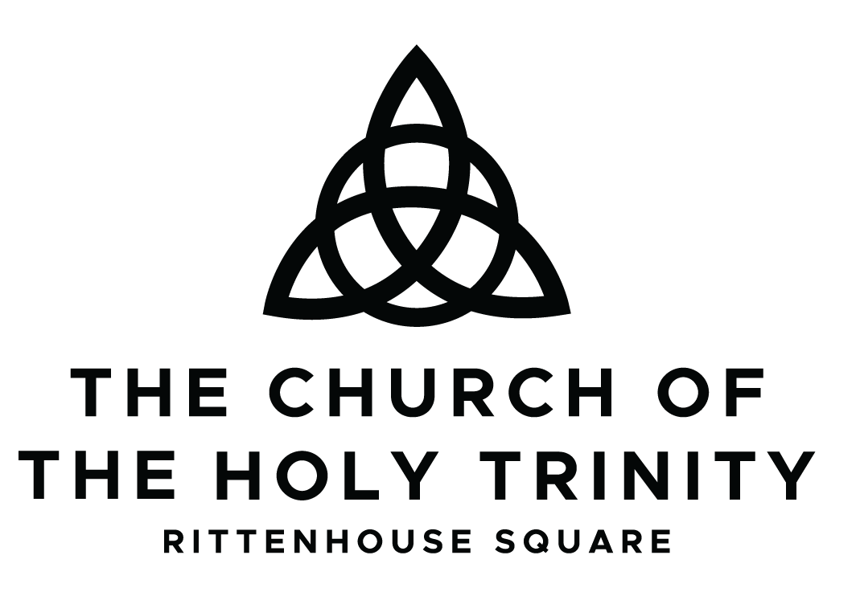

Wedding
Packet

Welcome!

Thank you for your interest in celebrating your wedding at The Church of the Holy Trinity. We are honored to be considered as the setting for your marriage, which we understand to be a sacred act of Christian worship.
This packet outlines our policies, process, and next steps. Please review it carefully before submitting your Wedding Inquiry Forms.

Contents

Booking Process for Weddings 3
General Policies 3
Wedding Fees & What’s Included 5
Wedding Needs & Information 6
Wedding Run of Show Template 7

Wedding Booking Process
- Initial Inquiry (either to rentals@htrit.org or through the website www.htrit.org)
- Church sends Wedding Packet to the couple.
- Couple submits Information, Needs & Run of Show (email or online)
- Staff will review availability and place a temporary hold for the desired date
- Clergy will review and approve the wedding (as applicable)
- The couple will receive the contract with fees.
- A deposit is due within 7 days of receiving the contract to secure date
- Signed contract due within 30 days of receiving.
- Final payment and documents due 60 days prior to wedding

General Policies (see contract for full details)
Nature of the Service
All weddings at The Church of the Holy Trinity are services of Christian worship. Those in the Episcopal Tradition follow the Book of Common Prayer or approved Rites and the Canons of the Episcopal Church.

Clergy
- Weddings are ordinarily officiated by Episcopal clergy
- Visiting clergy require approval from the Rector
- Rector must speak with visiting clergy at least 2 months in advance

Premarital Preparation (if using church clergy)
- 3–4 sessions required
- Must be completed 30 days prior to service.

Marriage Requirements
- At least one person must be a baptized Christian
- If marrying within the Episcopal Tradition:
  - Declaration of Intention is required
  - Bishop’s approval required for remarriage after divorce

Music
- Must be appropriate for Christian worship
- Coordinated with Organist and Choirmaster
- No pre-recorded music

Rehearsal
- Scheduled upon booking
- Attendance required for wedding party

Decor & Building Use
- No tape, nails, or adhesives
- Limited movement of furnishings
- Artificial petals only

Prohibited Items
- Alcohol (anywhere on property)
- Smoking
- Food in sanctuary
- Rice, birdseed, or sand ceremonies

Flowers
- Typically remain for Sunday service
- Delivery coordinated with Wedding Coordinator

Photography & Video
- Must be unobtrusive
- Stationary cameras only

Church Support
A Church Wedding Coordinator will be present for rehearsal and ceremony.

Fees & Payments
- $250 non-refundable deposit required to hold date
- Remaining balance due 60 days prior to wedding
- Additional fees may include:
  - Other musicians, extra cleaning, or more staff (depending on size)

Next Steps
Please complete and return to rentals@htrit.org:
- Wedding Information Form (pg. 5)
- Wedding Needs & Equipment Form (pg. 6)
- Preliminary Run of Show (pg. 7-8)

Wedding Fees & What’s Included

Wedding Package (Non-Parishioner)
$3,500 (all-inclusive ceremony package)*
Your wedding at The Church of the Holy Trinity includes:
- Officiating clergy
- Premarital preparation (3–4 sessions)
- Organist (church musician)
- Church Wedding Coordinator
- Use of the Sanctuary
- Rehearsal time
- Sound support (microphones as needed)
- Setup and basic coordination
- $300 charitable gift supporting Open Hearts Café

For weddings larger than 350 attendees, the fee will be $4,000.

Payment Schedule
- $250 non-refundable deposit due within 7 days of booking
- Remaining balance due 60 days prior to wedding

Additional Costs (If Applicable)
Some weddings may include additional costs based on your plans:
- Additional musicians (soloists, instrumentalists)
- Extended time beyond scheduled hours
- Additional staffing (if required)
- Livestream or A/V support
- Expanded facility use

Not Included
Couples are responsible for arranging:
- Flowers and décor
- Photography and videography
- Printed programs
- Transportation
- Reception or catering

Important Notes
- Weddings are sacred services of Christian worship in the Episcopal tradition
- All music, clergy, and ceremony elements are coordinated with church staff
- A Church Wedding Coordinator will guide you through rehearsal and the wedding day

Wedding Needs & Information Form
Couple Information
Name 1: __________________________ Name 2: __________________________
Phone: __________________________ Phone: __________________________
Email: __________________________ Email: __________________________

Wedding Details
Preferred Wedding Date: __________________ Preferred Time: __________________
Rehearsal Date (if known): __________________
Estimated Guest Count: __________________
Type
☐ Ceremony Only
☐ Ceremony + Reception (if applicable)
Clergy
☐ Church clergy
☐ Visiting clergy (name): __________________ denomination: ______________________________
Premarital Preparation (if applicable)
☐ Will participate with church clergy
☐ Will do counseling with alternative counselor (see form)
☐ Not applicable
Marriage History
Has either party been previously married?
☐ Yes ☐ No
(If yes, clergy will follow up regarding diocesan requirements)

Signed: _______________________________________ date: ____________________________
Signed: _______________________________________ date: ____________________________

Church Staff Approval: __________________________ date: ____________________________
Wedding Needs & Equipment Form
Spaces Requested
☐ Sanctuary ☐ Reception Hall
☐ Bridal Room ☐ Groomsmen Room
Equipment Needs
☐ Microphones ☐ Music stands
☐ Pew Candelabras ☐ Guest book table
☐ Livestream (if applicable)
☐ Other: __________________
*Please note, we do not do sand or candle ceremonies
Music
☐ Church musician: ☐ Piano ☐ Organ
☐ Outside (approval required): ☐ instrument _____________________________
Additional musicians/soloists: __________________

Florist Information Photographer/Videographer
Company: ______________________ Company: ______________________
Contact Name: __________________ Contact Name: __________________
Phone: _________________________ Phone: _________________________
Wedding Planner Information
Contact Name: ________________
Phone: _______________________
Email: _______________________
Special Requests or Notes

Signed: _______________________________________ date: ____________________________
Signed: _______________________________________ date: ____________________________

Church Staff Approval: __________________________ date: ____________________________
Wedding Run of Show Template
Couple Names: _____________________________________________________________________
Wedding Date: __________________________ Wedding Time: ___________________________
Timeline
Arrival Times
Couple arrival: __________
Wedding party arrival: __________
Vendors arrival: __________
Pre-Ceremony
Photos: ________________
Guest arrival begins: __________
Music begins: __________
Ceremony Order
Processional
Officiant: ☐ Yes ☐ No
Parents: ☐ Yes ☐ No
Wedding Party: ☐ Yes ☐ No
Couple entrance: __________________
Opening
☐ Welcome
☐ Collect
Readings
Reading 1: __________________ (Reader: __________)
Reading 2: __________________ (Reader: __________)
Sermon/Homily
☐ Yes ☐ No
Vows
☐ Book of Common Prayer
☐ New Rite for Marriage (non-gender based service)
Exchange of Rings
☐ Yes Who will be holding the rings? ____________________________________________________
Communion all are welcome to receive in the church
☐ Yes ☐ No
Music: (must be approved by Organist/Choirmaster or designated musician)
Processional

During Ceremony

Recessional

Post-Ceremony
Receiving line: ☐ Yes ☐ No
Photos in sanctuary: ☐ Yes ☐ No

Final Notes

Signed: _______________________________________ date: ____________________________
Signed: _______________________________________ date: ____________________________

Church Staff Approval: __________________________ date: ____________________________

